#include <iostream>

#include <windows.h>

using namespace std;

int main()

{

struct user{

string nama;

string kategory;

int jumlah;

};struct user gudang[100];

string nama,kategory;

int jumlah;

int n, top=-1,pil,i;

char yt='y';

cout << "Batas = ";cin>>n;

while(yt=='y'){

cout<<endl;

cout << "Pilihan :" << endl;

cout << "1.Push " << endl;

cout << "2.Pop " << endl ;

cout << "Select :" ; cin >> pil;

//fungsi Push

if(pil==1){

//Memasukkan Data

if(top==(n-1)){//deklarasi data penuh{

cout<<"\nData penuh!";

}

else{

cout<<"Masukkan Nama\t\t:";cin>>nama;

cout<<"Masukkan kategori\t:";cin>>kategory;

cout<<"Masukkan jumlah\t\t:";cin>>jumlah;

top++;

gudang[top].nama=nama;

gudang[top].kategory=kategory;

gudang[top].jumlah=jumlah;

}

}

//fungsi pop

else if(pil==2){

//Menghapus Data

if(top==-1){//deklarasi data kosong

cout<<"\nData kosong!";

}

else{

nama=gudang[top].nama;

kategory=gudang[top].kategory;

jumlah=gudang[top].jumlah;

top--;

cout<<"\nData "<<nama<<" Sudah Dihapus!"<<endl;

cout<<"\nData "<<kategory<<" Sudah Dihapus!"<<endl;

cout<<"\nData "<<jumlah<<" Sudah Dihapus!"<<endl;

}

}

else {

cout<<"\nError!"<<endl;

}

cout<<"Data : ";

if (top == -1)

{

cout<< "Kosong"<<endl;

}

else

{

for (i=0;i<=top;i++) {

cout<<"\nNama \t\t : "<< gudang[i].nama;

cout<<"\nkategori\t : "<< gudang[i].kategory;

cout<<"\njumlah \t\t : "<< gudang[i].jumlah;

}

cout<<"\nApakah anda ingin mengulang(y/n)";cin>>yt; system("cls");

}

}

Input

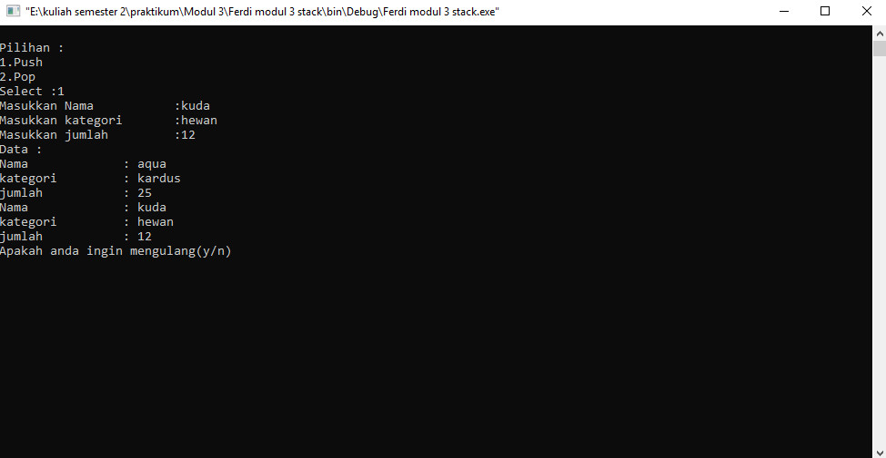

Output sesudah di hapus

